V1 28-4-26

HEREFORDSHIRE COUNCIL/GLOUCESTERSHIRE COUNTY COUNCIL

REINSTATEMENT OF HEREFORD-ROSS-GLOUCESTER RAILWAY

FEASIBILITY STUDY PROJECT BRIEF - TERMS OF REFERENCE DRAFT

MAY 2026

1. Introduction

1.1 Herefordshire Council/Gloucestershire County Councils, wish to
commission a feasibility study, to investigate restoration of the Hereford-Ross-on-Wye-Gloucester railway, as a through route, as part of the national rail network, connecting up to existing and potential new settlement proposals in the emerging Local Plans. Route plan attached.

2. Background

2.1 The Hereford, Ross and Gloucester Railway, was closed to passengers on 2 November 1964, as part of The Beeching cuts and subsequently dismantled. Freight services between Ross-on-Wye and Grange Court railway station continued on until 1 November 1965. The line ran for 22¹⁄₂ miles. The section between Grange Court Junction on the Gloucester-Newport line is still open and use by Cross Country and Transport for Wales services.

3. Current Situation

3.1 Herefordshire Council agreed on March 6 2026, to enter early discussions with Gloucestershire County Council, on the possibility of a joint feasibility study and to enquire with transport ministers about funding.

3.2 The proposal, which also seeks in parallel to test the market for any private finance interest in backing a feasibility study and has been welcomed by council leaders in Gloucester and the Forest of Dean.

3.3 The key justifications for the feasibility study are: -

- Establishment of a strategic rail corridor from the edge of England to the heart of London, Bristol and the South.

- Re-establishment of the rail link between two of the oldest English cities and the birthplace of British tourism.

- Provide an additional rail link from London and Bristol to South and West Wales, including ferry ports, avoiding the Severn Rail Tunnel.

- Enabling inward investment and a step-change in economic growth through strategic infrastructure investment in rail.

- Supports the pro-choice travel goal of LTP5 as well as its aim for equity of transport access for the less advantaged.

- Represents a modal shift in travel across the County and beyond.

- Allows the Councils to present a much more balanced package of transport infrastructure measures to the Govt for funding.

- Enables the start of an enhanced partnership with Gloucestershire, an important neighbouring authority.

- Put Herefordshire at the heart of the emerging revolution in delivery of rail services.

- (Subsequent developments in Ross are likely preclude reinstatement along the original route and require a deviation via Brampton Abbotts).

3.4 It was agreed on 6 March 2026 to: -

- Enter early discussions with Gloucestershire County Council on the possibility of a joint feasibility study on the re-establishment of the rail link.

- Write to the Secretary of State for Transport to and establish the likely support and possibility of funding for a feasibility study.

- In parallel, test the market for any private finance interest in
backing a feasibility study.

4. Engage with relevant partners and the engineering sector to seek
specialist expertise for writing and scoping a feasibility study,
including costs.

5. Report back on progress to Council within 12 months.

3.5 The Proposal would position Herefordshire to take early advantage of this move towards more local control of rail in shaping of the rail strategy. That should include making a central pillar of the upcoming rail strategy, a bold, ambitious and visionary commitment towards the re-establishment of the Hereford, Ross and Gloucester rail link.

3.6 This would then become one of the Councils fundamental goals of rail devolution in the Midlands, as well as forming a more rounded transport infrastructure offering to Government for funding. As a first step, the Council has agreed carrying out an initial feasibility study. In a local context the Council agreed the 5th Local Transport Plan in December, which aspires under Policy TN10 on rail to work with partners to enhance rail services across Herefordshire as well as long distance rail services with London and Birmingham. This would be underpinned by a supplementary Rail Strategy.

3.7 In a wider context, the Government landmark legislation, the Railways Bill, before Parliament last November, which will fundamentally alter the rail landscape in Great Britain. The Bill aims to nationalise trains and reform the railway, so it better serves passengers unveiling the new look Great British Railways, bringing track and train back together. It represents a new railway, focused entirely on delivering a proper public service for passengers. Mayoral strategic authorities (MSAs) will be able to apply for full statutory and financial responsibility for local rail services, infrastructure and/or control of stations (full devolution), where this accelerates improvements for passengers and supports a more integrated network.

3.8 Because of the recent changes in planned housing provision, the case for either of these options should be progressed as part of a wider strategy. Such a strategy would reflect the proposed cumulative scale of development in the study area, and the step-change increase implied by the new housing targets, identify the balance between local and strategic travel and identify which investments in transport infrastructure and services could best support their realisation. This would provide a holistic means of looking at the options emerging from this study as well as

3.9 Following an update to the National Planning Policy Framework (NPPF) in 2024 by the UK Government, the new standard method for calculating growth requirements, has set a 20-year housing requirement for Herefordshire of 27,260 dwellings. This will need to be accommodated along with the employment, educational, health, transport and environmental infrastructure to support that level of growth.

3.10 To ensure additional flexibility and choice when identifying development land, the aim is to identify sufficient land to accommodate approx. 30,000 dwellings with all other associated development required. 1,375 dwellings per annum, is a 78% increase. Herefordshire Council is beginning work on a new Local Plan for the period 2025 to 2045,

3.11 Gloucestershire County Council has been given a target of 43,000 new homes target. Dean Forest District Council’s new housing requirement, has increased from 6,600 dwellings over a 20-year plan period to a minimum of 12,000 over a similar period or 13,200 dwellings over the revised 22-year plan period. A new town location is being considered.

3.12 Gloucester City Council has a target of 732 dpa, a 10% increase from
the current method.

4. Project Brief

4.1 The purpose of the study is to: -

i). demonstrate that the rail corridor is of strategic transport
importance in connecting existing and proposed new
residential settlements on the rail corridor.

ii) to carry out further research to provide the necessary evidence
to demonstrate that this is a key corridor which requires
transport investment to support major economic growth/GVA
uplift for the benefit of the Midlands and UK plc.

iii). identify and assess proposed new housing and population
figures on County and District Council areas.

iv). to demonstrate that the study has considered the impact and
demand for rail travel, of a possible uplift in the number of
homes in the locality of the rail corridor.

v). the need to address climate change and infrastructure issues.

vi). To assess the potential benefits in terms of its
major investment and employment potential.

v). To consider the potential for a phased restoration of a rail service,
in the interests of affordability of both operational cost and
capital cost, e.g:-(a (heavy rail/tram train); (b). potential longer-
term restoration of heavy rail as part of a through inter-regional
route.

5. Other matters

5.1 To look at the broader regional impact of the reopening proposal, on both the direct area served between including new housing developments across the wider region. This includes impacts on communities already served.

5.2 These wider benefits will include increased access by communities to employment opportunities, increased local prosperity leading to
increases in regional GDP and improved business efficiencies together with wider economic benefits including employment, tourism and improved educational accessibility.

5.3 To give consideration to the potential effect on reducing road congestion and air pollution and the need to address climate change and infrastructure issues. A key objective of the study must be to reduce the car dependency by residents.

    - Road transport is already responsible for 80% of Nitrogen Dioxide emissions, which equates to approximately 29,000 deaths UK per annum linked with air pollution associated with road traffic. Rail accounts for 1.6%.

    - Road traffic currently accounts for 72% of total greenhouse gas (GHG) emissions from transport (73% of passenger-kilometres). Rail accounts for less than 1% (6% of passenger-kilometres).*
(*European Environment Agency (2019), ‘Share of transport greenhouse
gas emissions’, data visualization.)

    - The Government has a 2050 target to reduce emissions by 80%. Poor air quality is a major influence on public health, causing particular problems for those with respiratory illnesses and cardio-respiratory conditions.

    - Car ownership is high compared to county-wide and national levels.

    - The Hereford-Ross-Gloucester rail link would realise the latent demand for rail travel for committed population growth and tourism that is suppressed due to inadequate rail services. Roads cannot be provided on their own to meet demand, and may not be acceptable on environment and climate change grounds.

    - To recognise the role of rail as a regeneration tool that could benefit town centre regeneration on the rail corridor

          - As of May 2025, rail travel has returned to 97% of pre-covid levels.

5.4 The study should also include further analysis which may potentially enhance the core Hereford-Ross-Gloucester economic case, including the scheme’s potential to leverage and capture land value increases due to the introduction of new transport services. To underpin this, it is likely that a benchmarking review of other recent similar UK railway projects that have been completed will be undertaken and used to draw parallels from their economic benefits that have been realised.

6. Timescales, Budget and Tender Proposal
6.1 The proposed timetable for the project is set out below:
Tender submission by: xx 2026
Appointment w/c: xx 2026
Inception Meeting w/c: xx 2026
Draft report submitted w/c: xx 2026
Final report submitted w/c: xx 2026

6.2 The final timetable for the project will be reviewed if necessary and agreed at the inception meeting. However, it is anticipated the project will be completed within x weeks, starting from w/c xx 2026.
6.3 Consultants tendering for this contract should include in their proposals: -
- - A programme and timetable for undertaking the study reflecting the target dates as listed above;
- - Details of the requirements set out in Section 4 of this Brief, together with an indication of the sources of information to be employed and what information may be required from the Steering Group;
- - Details of the consultancy’s experience in this sphere of work, together with two contacts for references relevant to the study;
- - The names, details of the professional qualifications and experience of the team who would be undertaking the project;
- - Confirmation that undertaking this project would not give rise to conflicts of interest;
- - Full particulars of the pricing structure to be applied to the contract. - The pricing structure should show costs for each element of the study including time spent on the work, personnel involved, rates charged (including daily, hourly or fixed rate fees) and any expenses.
6.4 Fixed price tenders should be all inclusive with VAT charges shown
separately.

6.5 Tenders must be received by the Herefordshire Council by 1.00 pm on xx 2026.
6.6 The tender must be submitted electronically and the e-mail should bear the words: “Tender –Hereford-Ross-Gloucester Rail Study – not to be opened”.
6.7 The tender should be sent to the following e-mail address: X
and addressed for the attention of X.

6.8 No tender will be opened if it is received after the specified closing date and time.
6.9 Tenders will be assessed in accordance with the evaluation criteria to be sent out alongside this project brief.
6.10 The contract will be awarded on the basis of these criteria/scores alone. However, in the event of a ‘tie break’ situation, the relevant consultants will be invited to interview. Any interviews that are deemed to be necessary in order to assess the tenders and appoint the consultants, will be held during the week commencing xx 2026.
6.11 The successful consultant should allow for one progress meeting with the Steering Group (the date of which is to be decided at the Inception Meeting), and a presentation of the Final Rail Study to the Steering Group (either remotely or in person).
6.12 The consultant must be able to commence the study after the Inception Meeting, unless otherwise agreed.
6.13 The Herford-Ross-Gloucester Rail Study budget has a cost ceiling of £000. Any expenditure in excess of this figure would require the agreement of the Steering Group.

7. Selection of Consultants

7.1 Whilst cost is an important consideration for the X Herefordshire Council/Gloucestershire County Council/Steering Group, the contract will not necessarily be awarded to the lowest price. In determining the choice of the successful consultant, regard will be had to all factors in the attached evaluation criteria. The tender will be scored with a weighting of 60% towards quality and 40% towards cost. The overall objective of the evaluation process is to assess best ‘value for money’.

8. The Contract
8.1 Herefordshire Council/Gloucestershire County Council, is prepared to contract with the appointed consultant under the standard terms and conditions of the appointed consultant subject to the Council being satisfied that such terms and conditions are reasonable and acceptable.
8.2 The contract will be let on a fixed price contract including all appropriate expenses and costs.
8.3 The consultant should provide the particulars of public liability and professional indemnity insurances. Public Liability Insurance is required, with a limit of indemnity of not less than £5,000,000 (five million pounds) per claim or series of claims. In addition, the consultant must have Professional Indemnity Insurance with a limit of indemnity of not less than £2,000,000 (two million pounds) per claim or series of claims. The Professional Indemnity Insurance should be held in place for the length of the contract.
8.4 Payment will be made in three stages: 25% on inception, 50% on receipt of the draft report and the final 25% payment upon receipt of the final report to the satisfaction of the District Council/Steering Group.
8.5 The copyright of the final report and any appendices or other supporting information/outputs (including associated databases) will reside with X Herefordshire Council/Gloucestershire County Council.
8.6 Preliminary results of the arc rail study should be submitted in confidence to Herefordshire Council/Gloucestershire County Council, prior to compilation of the final report. This will allow any specific areas of concern to be identified for discussion with the consultant and will assist in ensuring that the study is in line with the Authority’s requirements.
9. Project Management
9.1 The project will be managed by Herefordshire Council/Gloucestershire County Council on behalf of the Steering Group organisations who have contributed to the cost of the Rail Study work. The Steering Group will be chaired by Herefordshire Council/Gloucestershire County Council and will also comprise representatives of:
- X Forest of Dean District Council
- X Gloucester City Council
- Midlands Connect
- Emerging shadow Combined Area Authorities.

9.2 Subject to the agreement of the Steering Group, representatives of the DfT, MHCLG, Great British Railways, Great Western Railway, West Midlands Trains, Network Rail, Transport for Wales, Homes England and developers, may be invited if thought necessary.
9.3 Steering Group meetings may be held online or in person or other venues along the study corridor that could facilitate site visits, should they be required.
9.4 Initial contact should be made with the Herefordshire Council’s contact for the project:
X Herefordshire Council.

9.5 Project management of the Study will be undertaken by X.

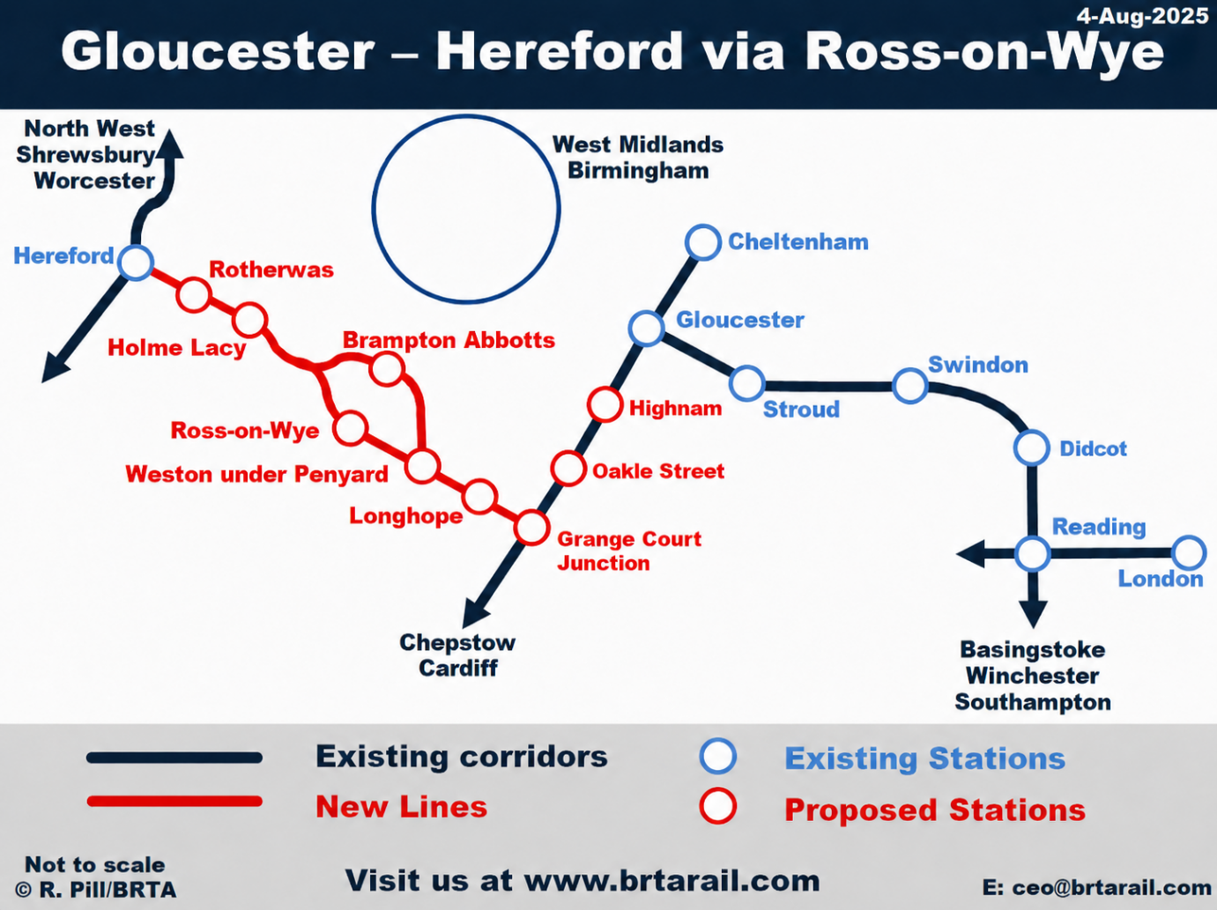
Image: BRTA.

